For release: 9th November 2017
14th – 16th November 2017, METStrade
Crewsaver Stand: 03.128, British Pavilion

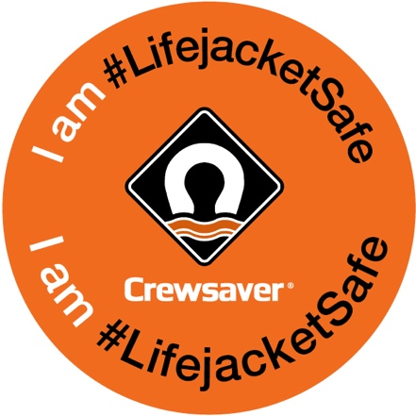
Crewsaver #LifejacketSafe campaign goes from strength to strength

The #LifejacketSafe campaign, launched by world-leading manufacturer of lifejackets and marine safety equipment, Crewsaver, is going from strength to strength. The campaign, which has been building momentum since its launch in September 2016, uses novel and interactive ways to help people stay safe on the water. The key aim of the campaign is to increase safety awareness of not only wearing a personal flotation device, but also making sure it is worn correctly and is well maintained, so it will not let the wearer down if the worst should happen.

Crewsaver’s #LifejacketSafe campaign newspaper, #LifejacketSafe challenge and lifejacket servicing reminders are just some of the ways in which the manufacturer is choosing to get its message across to consumers.

The idea behind the campaign is to combat the “I’m not planning on falling in…” mentality. The UK Maritime and Coastguard Agency states, “Accidents can happen at any time in any weather. Good training and common sense help, but lives could be saved every year if people wore correctly-fitted, well maintained lifejackets or buoyancy aids.” - MCA, (2014). Lifejackets Save Lives: Safety Advice From MCA

The #LifejacketSafe Newspaper
The free #LifejacketSafe newspaper is packed full of lifejacket safety tips, guest articles and games - all with the purpose of highlighting the importance of the trusted (and sometimes neglected) lifejacket! Readers of the #LifejacketSafe newspaper will get an insight into the importance of maintaining their lifejacket and discover ways they can keep their lifejacket action ready, should the unexpected happen.

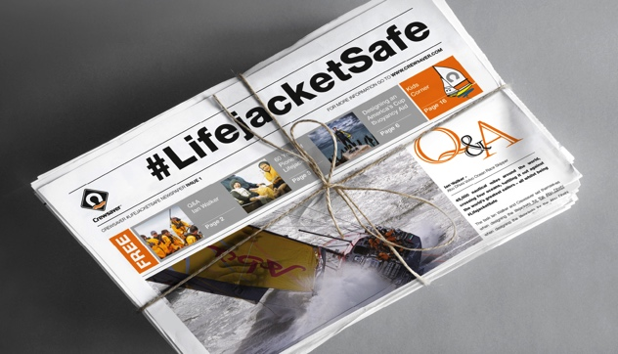

The #LifejacketSafe Challenge
The #LifejacketSafe Challenge is a quiz style challenge with thought-provoking questions highlighting lifejacket dos and don’ts. Not only could the advice learnt in the challenge save lives but also, by taking the challenge, entrants will be automatically entered into the prize draw to WIN the ultimate lifejacket package! Take the #LifejacketSafe Challenge here https://www.surveymonkey.co.uk/r/LifejacketSafe

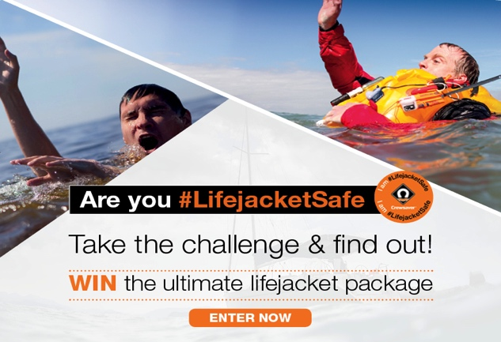
Put the LIFE back in your JACKET
Lifejackets and liferafts need to be well maintained and serviced to perform at their optimum. Crewsaver recognises the necessity of this and urges lifejacket and liferaft owners to register their products. Through Crewsaver’s enhanced product registration platform, Crewsaver will then send the owner a reminder of when their service may be due. Registering a Crewsaver lifejacket or liferaft is easy, owners simply head to the Crewsaver website with the serial number to hand and Crewsaver does the rest. To register, visit: www.crewsaver.com/uk/product-registration

#LifejacketSafe Information Centre
Watersport enthusiasts are encouraged to visit the #LifejacketSafe section of the Crewsaver website where they can access bite size #LifejacketSafe safety tips including; How to choose a lifejacket, FAQ answered and locate their nearest Crewsaver service station.

#LifejacketSafe On Tour
So far Crewsaver has taken its #LifejacketSafe campaign to various events across the world including London, Southampton and Sydney Boat Shows! Visitors to the Southampton Boat Show enthusiastically donned Crewsaver’s Fusion 3D lifejackets and got involved in the #LifejacketSafe selfie competition. At all events, the friendly Crewsaver team is on hand to speak with customers about the importance of lifejacket safety. Plus, all visitors are encouraged to try one of the company’s latest lifejackets to experience the huge advances made not only in lifejacket performance and style, but comfort too!

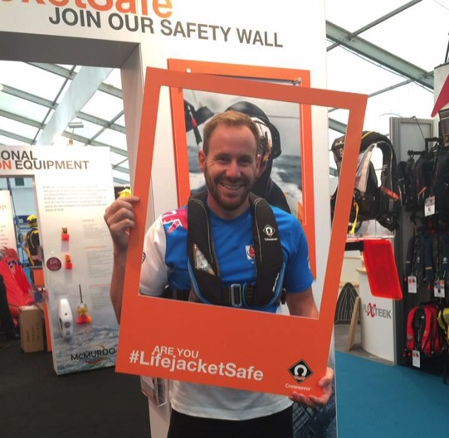

//ENDS//

For media information, hi-res images or product tests please contact:
Crewsaver
Hazel Proudlock, Marketing Dept
T +44 (0) 1329 820406
E hazel.proudlock@survitecgroup.com

Alison Willis – Marine Advertising Agency Ltd
T +44 (0) 23 9252 2044
E Alison@marineadagency.com

Notes to Editors

Crewsaver is a world-leading manufacturer of marine safety equipment and clothing for the commercial and leisure marine industries. Based in Gosport, Hampshire, the company designs and manufactures bespoke safety equipment for several countries’ Special Forces, and the aviation and oil industries. Crewsaver is the only company to hold an exclusive contract to supply lifejackets to the UK government’s Environment Agency and the Royal National Lifeboat Institution (RNLI). They are part of the Survitec Group.
www.crewsaver.com

Survitec Group is a global leader in survival and safety solutions to the marine, defence, aviation and offshore markets. Survitec has over 3,000 employees worldwide covering 8 manufacturing facilities, 15 offshore support centres and over 70 owned service stations. It is further supported by a network of over 500 3rd party service stations and distributors. Across its 160-year history, Survitec Group has remained at the forefront of innovation, design and application engineering and is the trusted name when it comes to critical safety and survival solutions. www.survitecgroup.com

