News Release

9th November 2017

Ancasta gears up for boat show season as CNB 66 announced for Boot Düsseldorf
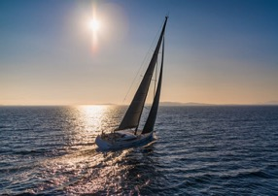

Ancasta is excited to announce that the new CNB 66 will be available to view at Boot Düsseldorf (20-28th January 2018). The beautiful CNB 66 redefines the possibilities of a 20m yacht. Her flowing, well-proportioned lines conceal an elegant, spacious interior. Ancasta can look at brokerage options for existing owners looking to move on to the CNB 66.

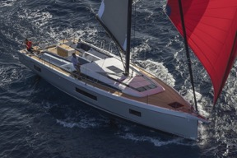
Both the Lagoon 40 and Lagoon 50 make their show debuts at Boot in 2018 and, as exclusive UK dealer for Lagoon Catamarans, Ancasta is uniquely positioned to help UK buyers wishing to view these sought-after multihulls. Prestige will be presenting the stand out Prestige 680, which will be the largest Prestige at the show. Since it’s launch, it has proved supremely popular and is unrivalled in the 68-foot motorboat market.
See the CNB 66 at Boot Düsseldorf with Ancasta

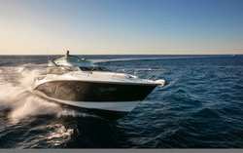
From Beneteau, highlights include the Oceanis 51.1, which made a splash with Alex Thomson at Southampton in September. On the power side, the sporty and distinctive Gran Turismo 50 SportFly, Beneteau’s flagship Sport Cruiser, should definitely be on visitors’ must-see lists.
See the Oceanis 51/1 at Boot Düsseldorf with Ancasta

Ancasta is delivering more new power and sailboats to customers across Europe, and will be on hand at Boot Düsseldorf to help UK buyers navigate the show. Interested buyers should contact Ancasta International Boat Sales (02380 450 000, www.ancasta.com) to arrange appointments to view. Ancasta also has a part-exchange capability above all others; anyone interested in this facility should get in touch to explore their options.
See the Gran Turismo 50 SportFly at Boot Düsseldorf with Ancasta

The impressive full list of boats on show is as follows:

CNB Yacht Builders

CNB 66

Prestige MotorYachts

Prestige 460/520/630/680

Beneteau Sail

First 20

Oceanis 35.1/38.1/41.1/45/51.1

Oceanis Yacht 62

Sense 51

Beneteau Power

Gran Turismo 40/50 Sportfly

Swift Trawler 35/44

Lagoon Catamarans

Lagoon 40/50

Contact Ancasta now to make an appointment to view any of the above, email enquiries@ancasta.com or call +44 2380 450000.

For more information visit:

https://www.ancasta.com/events/dusseldorf-boat-show-2018/

ENDS

Notes to editors
- Ancasta International Boat Sales has 14 offices across Europe
- Ancasta is the UK’s largest Prestige Luxury Motor Yachts dealer, the UK’s largest Beneteau Power and the UK’s largest Beneteau Sail dealer
- Ancasta is exclusive UK dealer for Lagoon Catamarans
- In addition Ancasta is a new boat dealer for CNB Yacht Builders and McConaghy Yachts
- The Ancasta Group incorporates Hamble Yacht Services Refit & Repair and Advanced Rigging and Hydraulics, both operating from Port Hamble.
- For more information on Ancasta visit www.ancasta.com
Media enquiries via Marine Advertising Agency: Alison Willis - alison@marineadagency.com Tel: 023 9252 2044

