For Immediate Release: 15.01.18
Boot Düsseldorf: 20.01.18 – 28.01.18
Crewsaver Hall 11, B42

Crewsaver to showcase the Atacama drysuit range at Boot Düsseldorf 2018

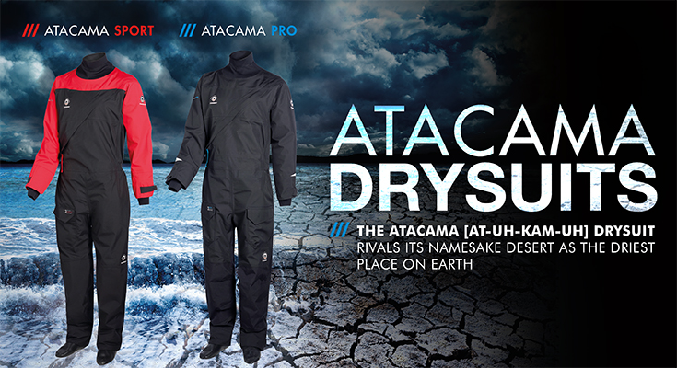
Visitors to Boot Düsseldorf 2018 will be able to head to the Crewsaver stand (Hall 11, B42) to view the newly released Atacama drysuits. With 3 layer breathable fabric, the Crewsaver Atacama Pro and Atacama Sport drysuits rival their namesake desert as the driest place on Earth. The Glideskin neoprene wrist and neck seals, plus latex socks, further help to keep the water at bay; meaning your boating doesn’t have to end when the summer season does. Both drysuits are designed to work with how the body moves, and incorporate articulated arms and legs for increased freedom of movement. In addition, the Atacama Pro has an integrated lower stretch mesh back panel with adjustable braces to create a bespoke custom-fit feel, without the price tag.

Head of Crewsaver’s design department, Nigel Parkes says, “We take great pride in the comfort offered by our products and this can certainly be seen in the flexibility and the ‘off-the-shelf-custom-fit’ style of each suit. Both the Atacama Pro and Atacama Sport are designed to work in harmony with the most demanding watersport enthusiast!”

Atacama Pro – RRP 559 Euros
Designed using 3 layer breathable technology and enhanced waterproof properties to keep you warm and dry whilst out on the water. Plus, Cordura reinforcement protects high-wear points such as the seat and knee; providing you with a drysuit that can keep pace with your demands.
- 3 layer breathable fabric with enhanced waterproof properties
- Lower back stretch mesh panel for increased comfort and flexibility
- YKK Aquaseal flexible zip construction
- Articulated arms and legs for increased freedom of movement
- Cordura reinforced double layered seat and knees
- Expandable leg pockets with D-ring attachment
- Adjustable wrist and ankle cuffs
- Glideskin neoprene wrist and neck seals
- Removable braces
- Internal pocket
- Reflective detail
Atacama Sport – RRP 499 Euros
Inspired by the Crewsaver Atacama Pro drysuit, the Atacama Sport includes an elasticated waist, adjustable braces and articulated arms and legs to provide unhindered freedom of movement. Additionally, reinforced seat and knees provide extra protection to the areas of high wear to enhance longevity.
- 3 layer breathable fabric
- YKK Aquaseal flexible zip construction
- Articulated arms and legs for increased freedom of movement
- Reinforced seat and knees
- Leg pocket with D-ring attachment
- Glideskin neoprene wrist and neck seals
- Elasticated waist
- Removable braces

Crewsaver products will be available for purchase from Crewsaver’s German distributor, Nordwest-Funk GmbH (Hall 11, B41) and retailer, LENZ Rega-Port GmbH & Co. KG (Hall 12, A31).

//ENDS//

For media information, hi-res images or product tests please contact:

Crewsaver
Hazel Proudlock, Marketing Dept
T +44 (0) 1329 820406
E hazel.proudlock@survitecgroup.com

Marine Advertising Agency Ltd
Alison Willis
T +44 (0) 23 9252 2044
E Alison@marineadagency.com

Notes to Editors

Crewsaver is a world-leading manufacturer of marine safety equipment and clothing for the commercial and leisure marine industries. Based in Gosport, Hampshire, the company designs and manufactures bespoke safety equipment for several countries’ Special Forces, and the aviation and oil industries. Crewsaver is the only company to hold an exclusive contract to supply lifejackets to the UK government’s Environment Agency and the Royal National Lifeboat Institution (RNLI). It is part of the Survitec Group.
www.crewsaver.com

Survitec Group Survitec is a global leader in survival and safety solutions to the marine, defence, aviation and offshore markets. Survitec has over 3,000 employees worldwide covering 8 manufacturing facilities, 15 offshore support centres and over 70 owned service stations. It is further supported by a network of over 500 3rd party service stations and distributors. Across its 160-year history, Survitec Group has remained at the forefront of innovation, design and application engineering and is the trusted name when it comes to critical safety and survival solutions.
www.survitecgroup.com

