For Immediate Release: 15.01.18
Boot Düsseldorf: 20.01.18 – 28.01.18
Crewsaver Stand: Hall 11, B42
DSB: Hall 10, C22

Leading Survitec brands, Crewsaver and DSB, announce attendance at Boot Düsseldorf

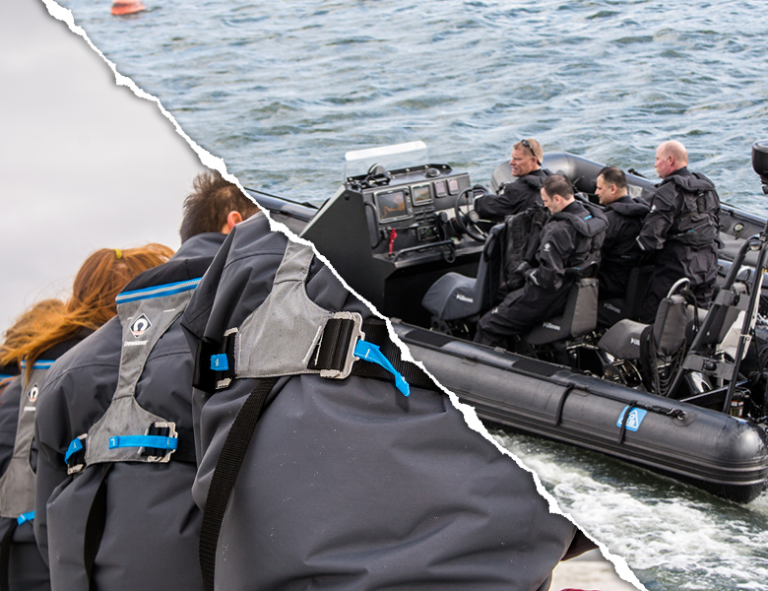
Crewsaver, a world leading designer and manufacturer of innovative personal lifesaving equipment, and DSB, masters in boat design, will be showcasing their pioneering product offering at Boot Düsseldorf.

DSB, renowned for the sturdiness of its designs and long product life, welcomes visitors to stand (Hall 10, C22) for specialist advice on its comprehensive boat range. On display will be the DSB 5.1SR; a semi-rigid inflatable boat designed and built to offer commercial marine and defence end-users with a product that incorporates maximum durability and increased manoeuvrability over an extended life cycle.
Visitors to the show are encouraged to join Crewsaver on its brand stand (Hall 11, B42) where they can view its pioneering product showcase, speak to the experts and get involved in Crewsaver’s popular #LifejacketSafe campaign. Alongside the popular Fusion 3D lifejackets and children’s lifejackets will be the newly released Atacama drysuits and Fusion 3D buoyancy aids! Crewsaver’s new range of buoyancy aids and drysuits have something very special to offer any watersport enthusiast and at every price point. Just like the popular Crewsaver Fusion 3D lifejacket range, the new buoyancy aids feature Fusion 3D technology to provide a uniquely unrestrictive, comfortable fit. The Atacama Pro and Atacama Sport drysuits, with their 3 layer breathable fabric, rival their namesake desert as the driest place on Earth. Crewsaver products will be available for purchase from Crewsaver’s German distributor, Nordwest-Funk GmbH (Hall 11, B41) and retailer, LENZ Rega-Port GmbH & Co. KG (Hall 12, A31).

Lifejacket Demonstrations
During the show, visitors will have the unique opportunity to see Crewsaver’s top-of-the-range lifejackets put to the test in lifejacket demonstrations held in Hall 14 by Richard Jeske from sailing school, Well Sailing. The live demonstrations will also be accompanied by on-stage interviews covering topics such as design of modern lifejackets, and useful, lifesaving accessories, plus tips for choosing the right model lifejacket for the job.

Saturday 20.01.18 12:00-12:30
Sunday 21.01.18 14:00-14:30
Wednesday 24.01.18 14:30-15:00
Friday 26.01.18 14:30-15:00
Saturday 27.01.18 12:15-12:45
Sunday 28.0118. 10:15-10:45

Are you #LifejacketSafe?
Whilst on the Crewsaver stand, visitors can also get involved in the #LifejacketSafe campaign. The campaign aims to increase safety awareness by highlighting the importance of not only wearing a personal flotation device, but also making sure it is worn correctly and is well maintained. So, if the worst should happen, watersport enthusiasts are well equipped and can rest assured that their safety equipment is not going to let them down.

- Pick up a free copy of the #LifejacketSafe newspaper. Now available in German as well as English
- Enter the #LifejacketSafe challenge, a quiz style challenge with thought-provoking questions highlighting lifejacket dos and don’ts. Not only could the advice learnt in the challenge save lives but also, by taking the challenge, entrants will be automatically entered into the prize draw to WIN the ultimate lifejacket package! Head to the Crewsaver stand to enter or take the #LifejacketSafe challenge here https://www.surveymonkey.co.uk/r/LifejacketSafe
- Register a lifejacket or liferaft to receive servicing reminders. Product registration is easy, visitors can simply pop over to the Crewsaver stand at the show to register at the interactive registration point. Alternatively, owners can head to the Crewsaver website and register online www.crewsaver.com/uk/product-registration

//ENDS//

For media information, hi-res images or product tests please contact:

Crewsaver: Hazel Proudlock, Marketing Dept
T +44 (0) 1329 820406
E hazel.proudlock@survitecgroup.com

Marine Advertising Agency Ltd: Alison Willis
T +44 (0) 23 9252 2044
E Alison@marineadagency.com

Notes to Editors - Crewsaver is a world-leading manufacturer of marine safety equipment and clothing for the commercial and leisure marine industries. Based in Gosport, Hampshire, UK, the company designs and manufactures bespoke safety equipment for several countries’ Special Forces, and the aviation and oil industries. Crewsaver is the only company to hold an exclusive contract to supply lifejackets to the UK government’s Environment Agency and the Royal National Lifeboat Institution (RNLI). It is part of the Survitec Group.
www.crewsaver.com

Survitec Group Survitec is a global leader in survival and safety solutions to the marine, defence, aviation and offshore markets. Survitec has over 3,000 employees worldwide covering 8 manufacturing facilities, 15 offshore support centres and over 70 owned service stations. It is further supported by a network of over 500 3rd party service stations and distributors. Across its 160-year history, Survitec Group has remained at the forefront of innovation, design and application engineering and is the trusted name when it comes to critical safety and survival solutions.
www.survitecgroup.com

