News Release

15th January 2018

Ancasta ready to present CNB 66 and Oceanis 51.1 at Boot Düsseldorf
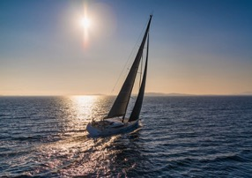

Ancasta is excited to be presenting the CNB 66 at Boot Düsseldorf (20-28th January 2018). The beautiful, CNB 66, was designed by Philippe Briand to be a large sailing yacht but one that could still be handled by a family crew. Her elegant lines conceal an abundance of volume, with a saloon that is entire beam-width, and a garage for a 3.25m tender. “We designed the hull with the triple objective of increasing the CNB 66’s volume, performance and seaworthiness.” – Philippe Briand, designer. Ancasta can look at brokerage options for existing owners looking to move on to the CNB 66.
See the CNB 66 at Boot Düsseldorf with Ancasta
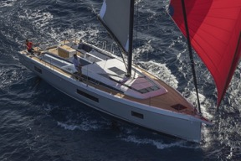

Ancasta is also presenting the Beneteau Oceanis 51.1 at Boot Düsseldorf. The Oceanis 51.1 is the first of a new generation, which can be configured in a host of different ways; create a smart priced charter boat, a comfortable cruiser or, by choosing a carbon rig, a performance cruiser.

Both the Lagoon 40 and Lagoon 50 make their show debuts at Boot in 2018 and, as exclusive UK dealer for Lagoon Catamarans, Ancasta is uniquely positioned to help UK buyers wishing to view these sought-after multihulls.
See the Oceanis 51.1 at Boot Düsseldorf with Ancasta

On show from Prestige will be a range of luxury motor yachts from the Prestige 460 right up to the stand out Prestige 680, which will be the largest Prestige at the show and is unrivalled in the 68-foot motorboat market.

Ancasta is delivering more new power and sailboats to customers across Europe, and will be on hand at Boot Düsseldorf to help UK buyers navigate the show. Interested buyers can find out more and make appointments to view at https://www.ancasta.com/events/dusseldorf-boat-show-2018. Ancasta also has a part-exchange capability above all others; anyone interested in this facility should get in touch to explore their options.

The impressive full list of boats on show is as follows:

CNB Yacht Builders

CNB 66

Prestige MotorYachts

Prestige 460/520/630/680

Beneteau Sail

First 20

Oceanis 35.1/38.1/41.1/45/51.1

Oceanis Yacht 62

Sense 51

Beneteau Power

Gran Turismo 40/50 Sportfly

Swift Trawler 35/44

Lagoon Catamarans

Lagoon 40/50

Contact Ancasta now to make an appointment to view any of the above, email enquiries@ancasta.com or call +44 2380 450000.

For more information visit:

https://www.ancasta.com/events/dusseldorf-boat-show-2018/

ENDS

Notes to editors
- Ancasta International Boat Sales has 14 offices across Europe
- Ancasta is the UK’s largest Prestige Luxury Motor Yachts dealer, the UK’s largest Beneteau Power and the UK’s largest Beneteau Sail dealer
- Ancasta is exclusive UK dealer for Lagoon Catamarans
- In addition Ancasta is a new boat dealer for CNB Yacht Builders and McConaghy Yachts
- The Ancasta Group incorporates Hamble Yacht Services Refit & Repair and Advanced Rigging and Hydraulics, both operating from Port Hamble.
- For more information on Ancasta visit www.ancasta.com
Media enquiries via Marine Advertising Agency: Alison Willis - alison@marineadagency.com Tel: 023 9252 2044

