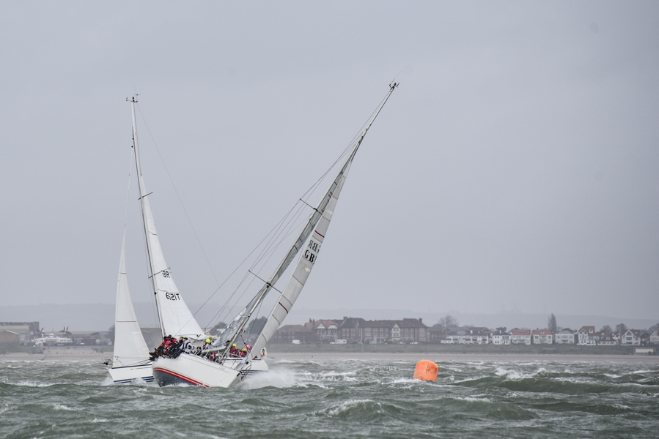
For Immediate Release: 14/03/18
Photo Credit: Close Hauled Photography

Crewsaver Warsash Spring Championship 2018

Getting the season off to a flying start on the UK’s South Coast is the Warsash Spring Series and Crewsaver Warsash Spring Championship! As it enters the third year of its sponsorship partnership with event organisers, Warsash Sailing Club, Crewsaver is delighted to announce that it will be donating a generous quiver of prizes to event entrants and volunteers.

The prizes!
In addition to well earned bragging rights, winners of the Crewsaver Warsash Spring Championship group categories will receive prizes from Crewsaver’s popular Fusion 3D lifejacket range, which includes the Crewfit 180N Pro and Crewfit 165N Sport. Crewsaver and Warsash Sailing Club also recognise the valiant efforts made by volunteers in making this event, now in its 61st year, such a success. As a thank you Crewsaver will be donating three Crewfit 180N Pro lifejackets to the bosuns and twelve Wet/Dry 75lt Holdalls, from Crewsaver’s NEW Watersports range, will be up for grabs in the event’s weekly draw!

Peter Bateson, Warsash Series/Championship Chairman: “We are delighted to be working with our long-standing sponsor Crewsaver again; it has been a solid supporter of the Spring Series and Championship for a number of years now and we are very grateful for its continued support. In addition to providing lifejackets to Championship group category winners, Crewsaver has been very generous in providing prizes from its new Watersports range for the weekly prize draw. Remember to come along to the Warsash Sailing Club after racing to be in with a chance of winning; the bar will be open and food is available”.
Are you #LifejacketSafe?
Race participants are strongly recommended to be #Lifejacketsafe when out on the water by wearing a personal flotation device that has been well maintained and is suitable for the conditions. To support this, Andark Diving and Watersports, in conjunction with Crewsaver, will be providing 15% off Crewsaver products (T&C’s apply) to entrants throughout Warsash Sailing Club’s spring racing events. Participants can find out more about being #LifejacketSafe by visiting the #LifejacketSafe section of the Crewsaver website, which can be found here http://crewsaver.com/uk/lifejacketsafe/

With over 300 enthusiastic sailors signed up for the Warsash Spring Series and Crewsaver Warsash Spring Championship, the much anticipated 2018 event promises not to disappoint. To enter the Warsash Spring Series and Crewsaver Warsash Spring Championship, visit http://warsashspringseries.org.uk/2018/index.htm.

//ENDS//

For media information, hi-res images or product tests please contact:

Crewsaver
Hazel Proudlock, Marketing Dept
T +44 (0) 1329 820406
E hazel.proudlock@survitecgroup.com

Alison Willis – Marine Advertising Agency Ltd
T +44 (0) 23 9252 2044
E Alison@marineadagency.com

Notes to Editors

Crewsaver is a world-leading manufacturer of marine safety equipment and clothing for the commercial and leisure marine industries. Based in Gosport, Hampshire, the company designs and manufactures bespoke safety equipment for several countries’ Special Forces, and the aviation and oil industries. Crewsaver is the only company to hold an exclusive contract to supply lifejackets to the UK government’s Environment Agency and the Royal National Lifeboat Institution (RNLI). They are part of the Survitec Group.

www.crewsaver.com

Survitec Group Survitec is a global leader in survival and safety solutions to the marine, defence, aviation and offshore markets. Survitec has over 3,000 employees worldwide covering 8 manufacturing facilities, 15 offshore support centres and over 70 owned service stations. It is further supported by a network of over 500 3rd party service stations and distributors. Across its 160-year history, Survitec Group has remained at the forefront of innovation, design and application engineering and is the trusted name when it comes to critical safety and survival solutions.
www.survitecgroup.com

