**News Release**

**For immediate release**

**5th June 2018**

**Ancasta gears up for Poole Harbour Boat Show (8th-10th June 2018)**

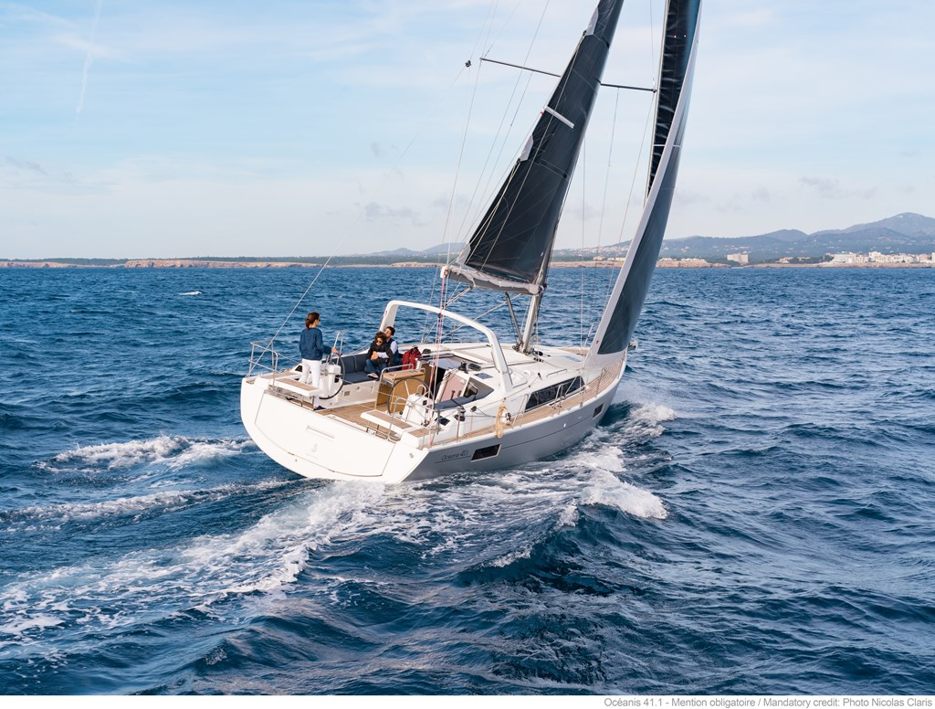Ancasta is gearing up for Poole Harbour Boat Show 2018, which takes place from 8th-10th June 2018. Ancasta will be representing both Beneteau Sail and Beneteau Power at the show. On display will be an Oceanis 41.1 from Beneteau Sail and from Beneteau Power, the Swift Trawler 30 and 35 as well as the Gran Turismo 40.

To better serve those selling or looking to buy a boat in the area, Ancasta now has a dedicated broker for Poole and Portland, Kevin Macdonald, who visitors will be able to meet at the show. Kevin and the other members of the Ancasta team attending the show look forward to welcoming visitors to berths A49-46 by the entrance to the marina.

The Beneteau Oceanis 41.1

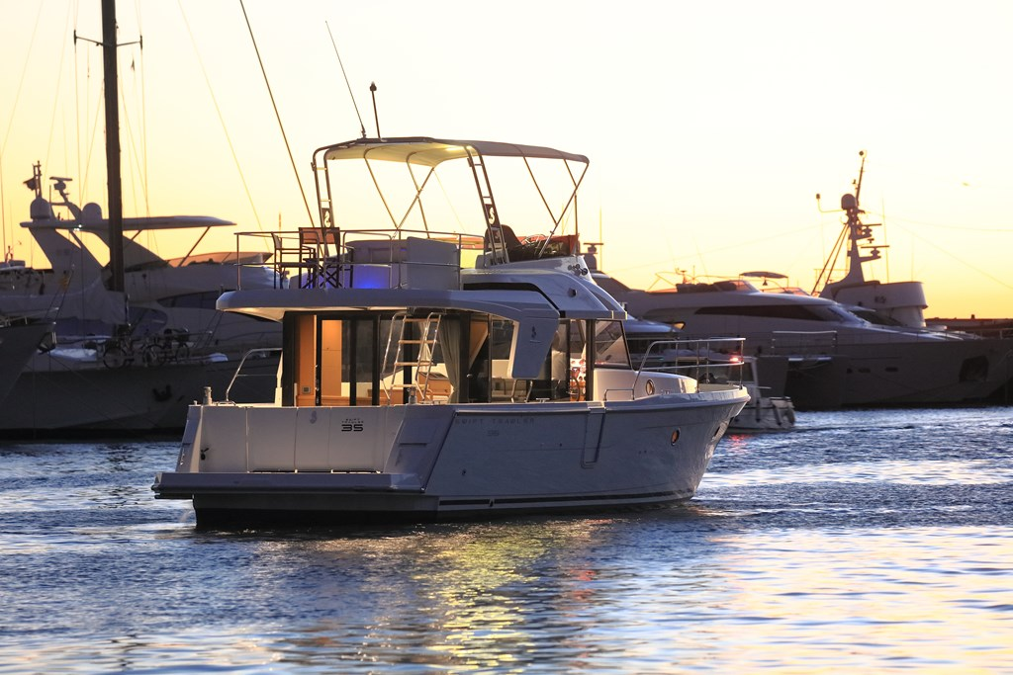ON SHOW - The Beneteau Oceanis 41.1 is designed with a Finot-Conq hull and Nauta interior. The Oceanis range continues to offer a variety of different layouts, from number of cabins and bathrooms to a choice of galley layout, enabling clients to customise their boats to suit their style of sailing.

A finalist in the Motor Boat Awards 2018, the Swift Trawler 35 is the newest in the range. She has a distinctive long distance cruising temperament, prioritising safety and boasting a spacious interior. The hugely successful Swift Trawler 30 has an ingenious rear cockpit that converts into a spacious terrace over the sea – definitely a must-see. Also on display is the sporty Gran Turismo 40, which reinvented the sports cruiser concept and combines space, power and speed.

The Beneteau Swift Trawler 35

Poole Harbour Boat Show is open Friday 8th, Saturday 9th and Sunday 10th June from 10am to 5.30pm.

To arrange appointments to view, please contact Ancasta on 02380 450 000 or email [enquiries@ancasta.com](mailto:enquiries@ancasta.com).

For more information visit <https://www.ancasta.com/events/poole-harbour-boat-show-2018/>

**ENDS**

**Notes to editors**

* Ancasta International Boat Sales has 15 offices across Europe
* Ancasta is the UK’s largest Prestige Luxury Motor Yachts dealer, the UK’s largest Beneteau Power and the UK’s largest Beneteau Sail dealer
* Ancasta is exclusive UK dealer for Lagoon Catamarans
* In addition Ancasta is a new boat dealer for CNB Yacht Builders and McConaghy Yachts
* The Ancasta Group incorporates Hamble Yacht Services Refit & Repair and Advanced Rigging and Hydraulics, both operating from Port Hamble.
* For more information on Ancasta visit www.ancasta.com

Media enquiries via Marine Advertising Agency: Alison Willis - [alison@marineadagency.com](mailto:alison@marineadagency.com), tel: 023 9252 2044