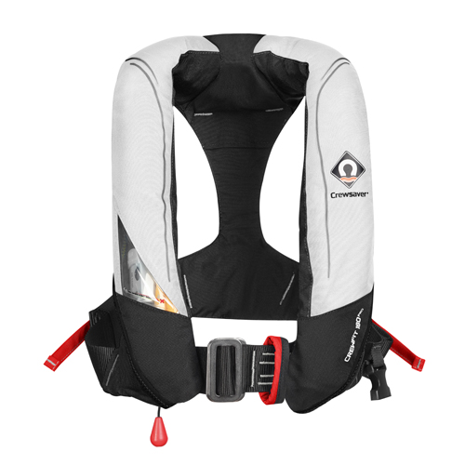
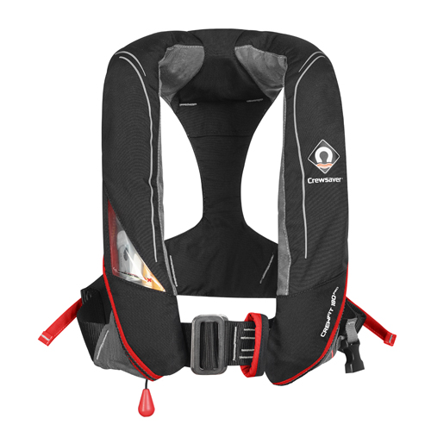

Featuring new colours and a heavy duty option, Crewsaver’s new Crewfit 180N Pro lifejackets will be available for the first time at TheYachtMarket.com Southampton Boat Show

Continuing to lead the way in comfort, style and performance for lifejackets, Crewsaver is excited to reveal the chic new colours and the heavy duty addition to the Fusion 3D Crewfit 180N Pro lifejacket range.

Coming to the market in time for TheYachtMarket.com Southampton Boat Show which takes place in September, the Crewfit 180N Pro will be available in two new colours - black and red, and white and red. Forever looking to increase safety and performance, these new colourways will also include a FREE surface lifejacket light (RRP £22) fitted as standard – resulting in an increased in-water visibility at no extra cost to the user.

Further to the new colourways, the Crewsaver Fusion 3D range will have a heavy duty option - the Crewfit 180N Pro HD. This features 500D heavy duty front body panels to provide maximum durability, as well as reflective tape on the cover to help achieve maximum visibility. This lifejacket is perfect for those working in the marine environment including marina and charter boat operatives, as well as leisure users such as fishermen looking for that next level in durability.

Crewsaver’s Marketing Manager, Hannah Burywood says – “When we launch a range, we don’t stop working. We push ourselves to provide the very best in fresh designs as well as safety performance. We want people to feel safe, stylish and comfortable on the water, whether at work or at play. The introduction of the new Crewfit 180N Pro colours with a free lifejacket light, and the inclusion of the heavy duty option, adds fresh new options and increased safety technologies to our range.”

The new Crewfit 180N Pro colourways and heavy duty option will be available at TheYachtMarket.com Southampton Boat Show. Find Crewsaver at the show on associated retailers’ stands, where a friendly representative will be on hand to discuss any safety requirements visitors may have.

Join Crewsaver at TheYachtMarket.com Southampton Boat Show at the following;

- Andark Diving & Watersports

- Force 4 Chandlery
- Marinestore
- Marine Superstore

RRPs start at £95. Find out more about the Crewfit 180N Pro and / or the Crewfit 180N Pro HD at Crewsaver.com

//ENDS//

For media information, hi-res images or product tests please contact:

Crewsaver
Hazel Proudlock, Marketing Dept
T +44 (0) 1329 820406
E hazel.proudlock@survitecgroup.com

Alison Willis – Marine Advertising Agency Ltd
T +44 (0) 23 9252 2044
E Alison@marineadagency.com

Notes to Editors
Crewsaver is a world-leading manufacturer of marine safety equipment and clothing for the commercial and leisure marine industries. Based in Gosport, Hampshire, the company designs and manufactures bespoke safety equipment for several countries’ Special Forces, and the aviation and oil industries. Crewsaver is the only company to hold an exclusive contract to supply lifejackets to the UK government’s Environment Agency and the Royal National Lifeboat Institution (RNLI). They are part of the Survitec Group. www.crewsaver.com

Survitec Group Survitec is a global leader in survival and safety solutions to the marine, defence, aviation and offshore markets. Survitec has over 3,000 employees worldwide covering 8 manufacturing facilities, 15 offshore support centres and over 70 owned service stations. It is further supported by a network of over 500 3rd party service stations and distributors. Across its 160-year history, Survitec Group has remained at the forefront of innovation, design and application engineering and is the trusted name when it comes to critical safety and survival solutions. www.survitecgroup.com

