News Release

For immediate release
21 May 2019

THE SOUTH COAST BOAT SHOW JUDGED A
STUNNING SHOWCASE FOR GLOBAL POWER AND SAIL BRANDS

Over 60 innovative sail and power boats were on display at Ocean Village Marina last weekend, and what a sight it was with all major global brands represented on the water.
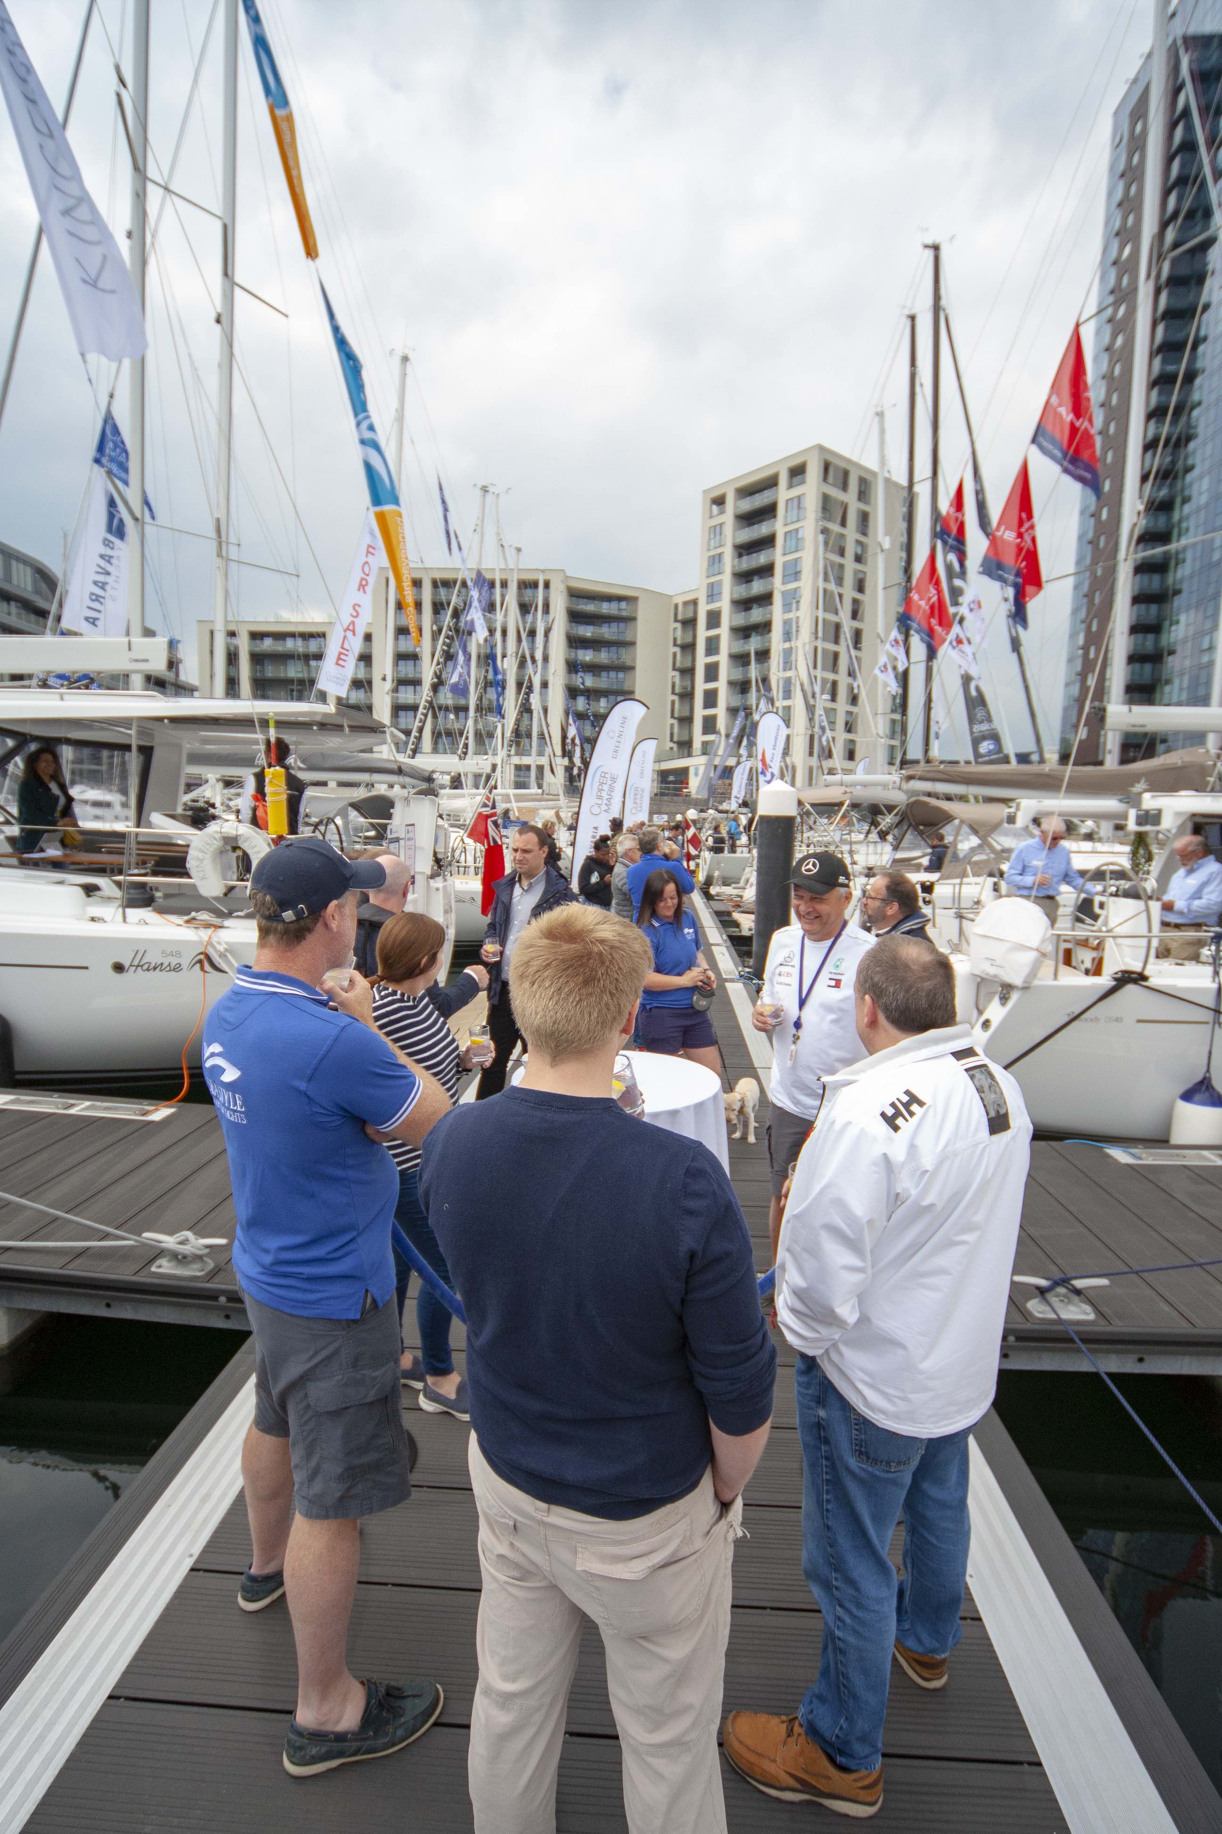
Organised by a consortium of south coast dealers, Ocean Village Marina was chosen as the location for this new event, with its deep-water, access at all states of the tide, stunning backdrop of the Harbour Hotel and superyachts berthed in the background. It was the perfect setting for brands which included:

Arcona Yachts, Axopar London Group, Bavaria, Beneteau power and sail, BRIG RIBs, Broadblue England and R400, Chaparral Boats, Dazcat, Dehler, Dragonfly, Dufour Yachts, Elan, Ferretti Yachts, FinnMaster, Fountaine Pajot, Galeon, Galia, Grand, Greenline Yachts, Hallberg-Rassy, Hanse, J-Boats, Jeanneau power and sail, Lagoon Catamarans, MAREX, Marlin, Najad Yachts, Nautitech Catamarans, Nimbus Boats, Nord Star, Numarine, Ocqueteau, Parker Boats, Rapier Catamarans, Sargo, Sasga Yachts, Seaward, Spectre Boats Int, Stingher, Targa and X-Yachts.

The South Coast Boat Show will now become a secured event in the marine calendar, and already has the colloquial nickname of ‘the buyers’ show’ for its no-frills approach.

Scott Farquharson, MDL’s Ocean Village Marina manager, organised the site and was delighted with its success.

“The objective was that this show was all about the boats,” he says. “We wanted visitors to have the time and space to access what they wanted to see, and to have in-depth conversations about their requirements without being bustled along. It was perfect. We enjoyed a glorious mix of power, sail and cats on display. Plus, Prolific (Ocean Youth Trust, South) was there, welcoming people on board to talk about the brilliant work they do with young adults, and serving bacon rolls for a charitable donation.”

Plans are already afoot for next year’s event.

“We need something like this in the diary,” Scott continues, “There are a lot of shows springing up around the country to help fill the gap in national events. This one is for those looking to make a serious investment in a global brand. We’re already welcoming expressions of interest from existing, and new, exhibitors.”

This is underpinned by one of the consortium organisers.

“The feedback has been amazing,” says Will Bair, from Ancasta International Boat Sales. “It’s definitely a buyers’ show with space given to really compare and contrast between brands and models. All visitors seemed to enjoy the access they had to the broad range of product and information from the dealers that were on hand.”

For more information about next year’s South Coast Boat Show keep an eye on: southcoastboatshow.com or contact info@southcoastboatshow.com.

ENDS

Images
High res images are available online: https://maa.agency/media-centre/

MAA
- MAA provides simple, no-nonsense solutions to marine companies’ advertising, PR, media buying and communications needs.
- From brand development and marketing materials to website, eCommerce, email campaigns and social media, MAA offers a straightforward, knowledgeable and service-orientated approach.
- MAA is able to offer unrivalled value to help clients reach their target markets.
- For more information visit www.maa.agency

For further information contact:

Zella Compton or Mike Shepherd
Zella@maa.agency Mike@maa.agency
023 9252 2044 023 9252 2044

