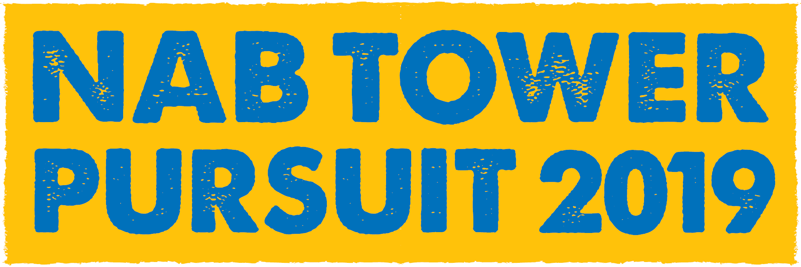

News Release
For immediate release
18th June 2019

Nab Tower Pursuit 2019 raises over £4,500 for charities

The Nab Tower Pursuit got off to a fine start at 10am on Saturday the 15th June. They left GAFIRS slipway buoy, with SALT HEART, skippered by Kevin Raine, leading the way. The Mayor of Gosport Kathleen Jones, her husband and several other VIPs were able to watch the Pursuit from the fast patrol launch HSL102. A brisk southerly breeze helped the yachts as they began the Pursuit out to the Nab Tower, a distance of some 10 miles.

All yachts finished by just after 2pm and were able to get ashore and prepare for the evening’s festivities. The prize-giving took place at Hornet Services Sailing Club and our principal VIP, the Mayor of Gosport Kathleen Jones, graciously agreed to present them. ASSASSIN, skippered by Mark Brown, was this year’s overall winner, having accumulated the most points. Mark took home the Gosport Challenge Cup as well as a lift-out and relaunch for his yacht, courtesy of Premier Marinas’ Endeavour Quay.

The most contested prize was awarded to the yacht that raised the most amount of money for their chosen charity. The prize went to BOMBADIER III skippered by Matthew Sleap, which was sponsored by Abby Thomson’s Sisters Inn Arms. They raised £866 for the Step by Step charity.

Other prize-winners and the full Pursuit results can be viewed on the website and Facebook page. There are also many splendid images available online, courtesy of the world-famous Tall Ships photographer, Max Mudie. A special mention must also go to our sponsors: You Boat Chandlery, Sisters Inn Arms Alverbank Hotel, Premier Marinas and ASTO.

Charities who benefitted from the event include Oarsome Chance, The James Myatt Memorial Trust, Cancer Research UK, Alzheimers Research UK, the Jo Glover Trust, Step by Step and Gosport Marine Futures, the charitable arm of Gosport Marine Scene that provides opportunities for local Gosport and Portsmouth youngsters to engage with all things marine and maritime.

Hornet Services Sailing Club, who hosted the event for GMS, laid on a superb barbecue, and a special thanks must go to Arty Shaw and his excellent team.

Nab Tower Pursuit Director Peter Newell says: “Another highly successful Pursuit to the Nab Tower and back, our fourth organised by Gosport Marine Scene, with some quite challenging weather and the occasional rain squall, which all participating yachts were able to deal with well. All skippers and crews are to be congratulated on making the most of a very enjoyable event while, at the same time, raising over four and a half thousand pounds for their chosen charities. We look forward to seeing them return next year with their sights set on raising even more money for their charities.”

We’re already looking forward to next year’s Nab Tower Pursuit, scheduled to take place on Saturday 13th June 2020. Make a note in your diary now!

ENDS

Media enquiries:

For further information and requests for interviews, please contact:
Mike Shepherd
Tel.: 023 9252 2044; or mobile 07786 265 455
Email: mike@maa.agency

GMF MD contact details:
Mark Bowden
Tel: 07802 650623
Email: mark@gosportmarinescene.com
Notes for Editors

About Gosport Marine Scene and Gosport:
Organiser of Gosport's:
Marine Business Network, Gosport Marine Festival
Talent & Career Programme
Gosport Peninsula is a centre of excellence in ocean racing, sail training, marine tourism and trade.
Gosport is the home of: Alex Thomson Racing & Hugo Boss, Clipper Round the World Race, Global Ocean Race, Sail Training International, ASTO, Ocean Youth Trust South, Lee-on-Solent RYA Onboard, Toe in the Water . . . just for starters.

